Q: Why are we switching to LED streetlights?

A: The City of Pendleton joins cities throughout Oregon and the rest of the world in switching to LED lights to save money and energy while reducing carbon emissions and maintenance costs. LED lights consume up to 50 percent less energy and have a longer life span than the traditional high-pressure sodium lights. The reductions from using LED technology help the City achieve our sustainability and carbon reduction goals.

Q: Are all the City streetlights being replaced?

A: The project will replace an estimated 1,005 existing high-pressure sodium streetlight fixtures on the City’s public streets. Not included in the project are City streetlights that already have LED fixtures and additional streetlights in the City that are on state highways or private streets that are operated by other entities and are not included in this project.

Q: How will traffic be impacted by the installation of the LED streetlights?
A: For the safety of the traveling public and the construction crews, there will be rolling short-term closures of parking lanes, bike lanes, or sidewalks as the new streetlight fixtures are installed. In some cases where shoulder access to the streetlights is limited, travel lane closures may also be required. To minimize traffic impacts, the Contractor will make every effort to schedule the work during times of low traffic volumes and to keep the duration of lane closures as brief as possible. Crews plan to replace up to 40 fixtures a day, so we appreciate your patience while they are working in your area. Check the weekly traffic updates at https://pendleton.or.us/projects for any LED project closures.

Q: Can I get a new streetlight or move an existing streetlight?
A: No, this project only converts the existing fixtures. No new or relocated lights are included. New streetlights are installed with City capital improvement construction projects or with new development. There is no funded program to add or move streetlights on a request basis.

Q: How is the new LED light different?

A: The LED lights have a slightly different color, enhance visibility, and direct light differently than the existing non-LED lights. The existing high-pressure sodium (HPS) streetlights have a more yellow color, and the new LED streetlights provide fuller spectrum warm light that may appear more white than yellow. The fuller spectrum light enhances peripheral vision for drivers, enables people to distinguish color more accurately, and improves detection of obstacles in the road. Also, the LED lights are more downcast than the existing HPS lights, so light is directed below the light where it is needed with less illumination above the light.
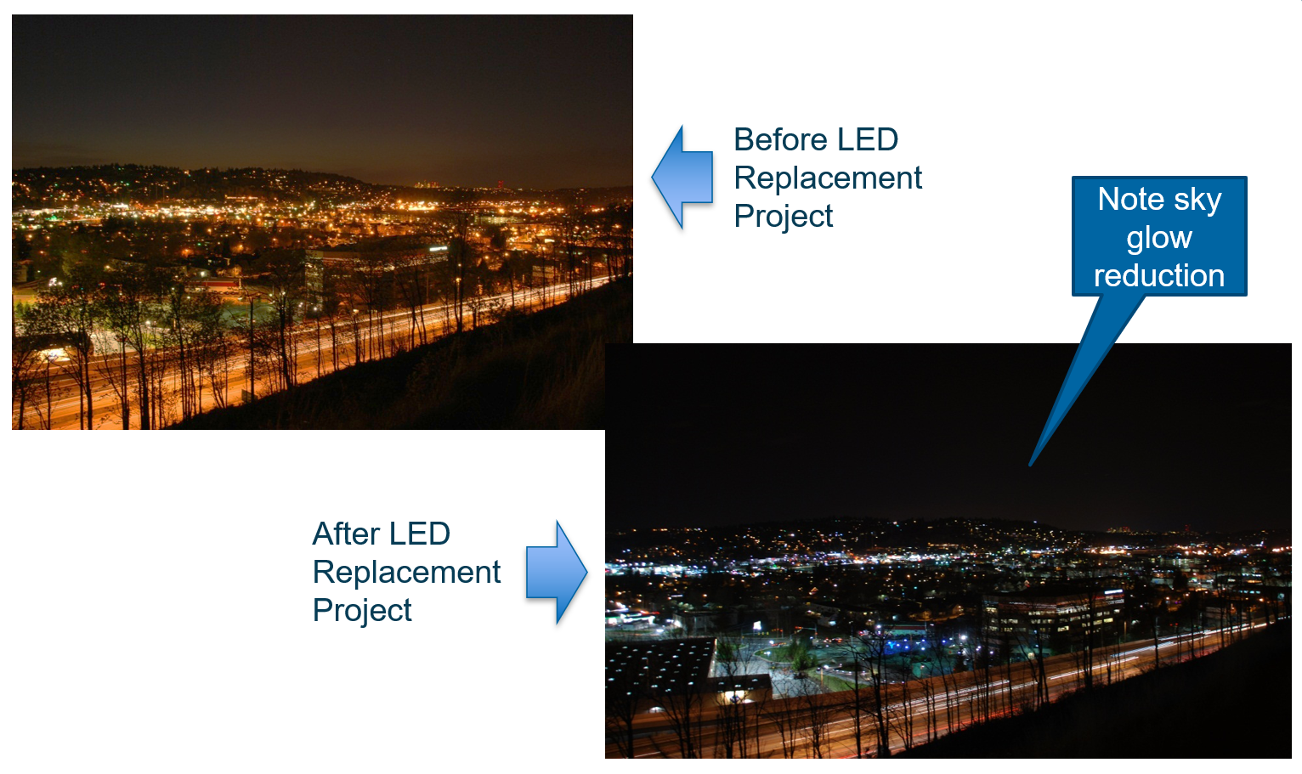
1 - City of Renton, WA Before & After LED Conversion – Significant night sky glow reduction and color temperature change
Q: How is the City paying for this project? Will this cost the taxpayers/ratepayers anything?
A: This project is budget-neutral to the City. The energy savings fully funds the project, costing zero taxpayer/ratepayer dollars and uses zero up-front capital.

Q: How will I know when the streetlights are changed?
A: The project will run from June through August 2022. Check the project website at https://experience.arcgis.com/experience/5eb1dd358cf7459ca57332d2f705b564 to see the areas of the City where the LED fixtures have been installed and the percent of the conversion that has been completed. .

Q: Who do I contact if a replaced LED streetlight is not working or there is another issue with the LED conversion project?

A: For answers to general project questions and project status check the website above. For additional information email PendletonLEDStreetlights@gmail.com or call contact the Public Works Department at (541)-966-0202.

