City of Pendleton
Human Resources Manager

About the Community
Located at the base of the beautiful Blue Mountains in Eastern Oregon, this agriculturally-based rural community is an outdoor enthusiast and sportsman’s paradise. Well known for its world-class Pendleton Round-Up rodeo, the area also boasts hunting, fishing, skiing, snowshoeing, cycling, hiking, and many other recreational activities. The City of Pendleton also enjoys a thriving arts culture with a wonderful art center, community theater, and many historic attractions. Combined with clean air, good schools, and an active community college, Pendleton is a vibrant and family-friendly community. The City serves a population of about 17,000.

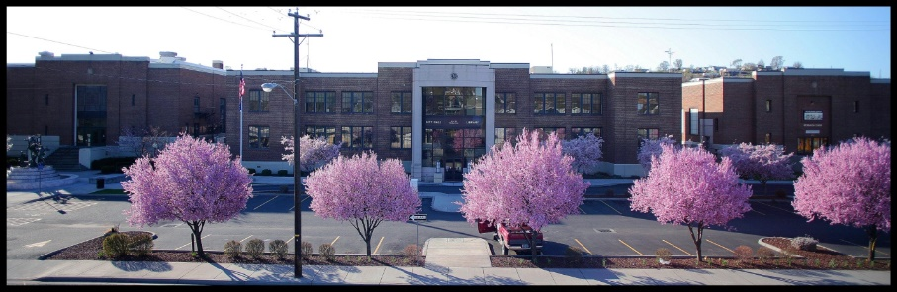
About the Department
The Human Resources/City Recorder position is in the Administration Department which also includes the City Manager, administrative support, communications, legal, and the Mayor’s office. Administration serves all departments including: Police, Fire, Airport, Convention Center, Facilities, Parks & Recreation, Finance, Community Development, and Public Works. The City of Pendleton employs over 200 career staff, plus 60-100 seasonal workers. City administration actively pursues continual process improvement adopting the tagline of “Working every day to be the premier City in Eastern Oregon.”

About the Position
The HR Manager is responsible for managing all human resources programs including recruitment and selection, labor and employee relations, personnel and administrative policies, classification and compensation, employee benefits, and risk management including administration of the workers’ compensation program. The City is looking for someone with a progressive approach to human resource management that strives to maintain best practices in all HR programs. Position also acts as City Recorder which includes responsibility for City records, elections and Council agendas and minutes. A bachelor’s degree in HR, Business, Public Administration, or a related field, and five (5) years of progressively responsible HR experience is required. Must possess a working knowledge of human resource practices, public sector administration, risk management and safety practices, and records management techniques, as well as experience assuring compliance with applicable laws; and the ability to work effectively with employees, City officials, labor unions and the general public.

Salary range: $94,320 – 118,886 DOE. Excellent benefits package includes: medical; dental; vision; retirement; life insurance, and more.

To Apply
Applications are available on our website at www.pendleton.or.us/employment or at City Hall, 500 SW Dorion, Pendleton OR 97801. For additional information, please contact Human Resources at 541-966-0201. The City of Pendleton is proud to be an Equal Opportunity employer.

