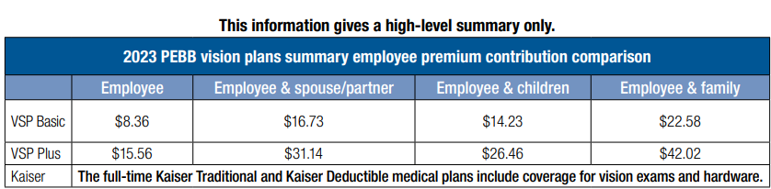
Employee Share
Basic | $0.75 | $1.51 | $1.28 | $2.03
Plus | $1.40 | $2.80 | $2.38 | $3.78

