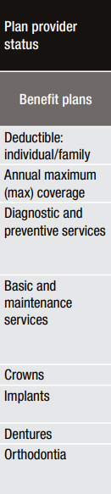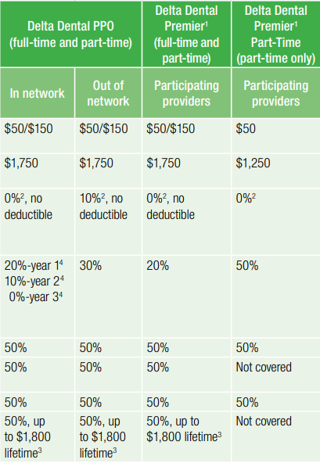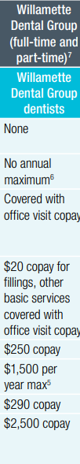
Dental Premium | Total | Employee | Total | Employee | Total | Employee
 | Delta PPO | Share | Delta Premier | Share | Willamette | Share
EE Only | $57.57 | $5.18 | $62.31 | $5.61 | $55.16 | $4.96
EE+ Child(ren) | $97.87 | $8.81 | $105.90 | $9.53 | $93.84 | $8.45
EE + Spouse | $115.12 | $10.36 | $124.59 | $11.21 | $110.33 | $9.93
Family | $155.43 | $13.99 | $168.21 | $15.14 | $149.00 | $13.41
