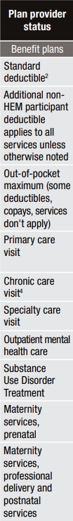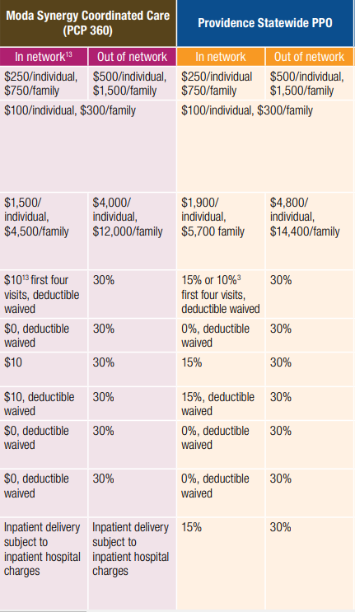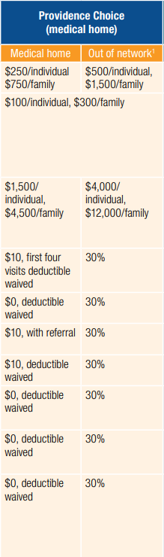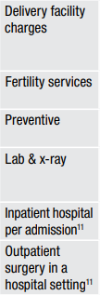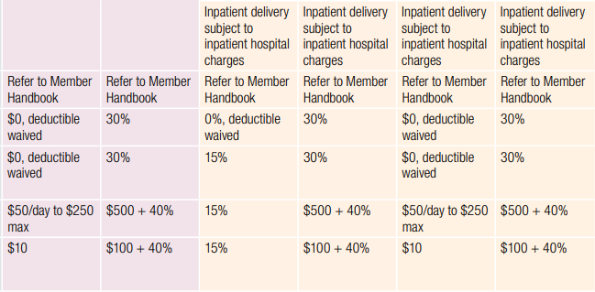
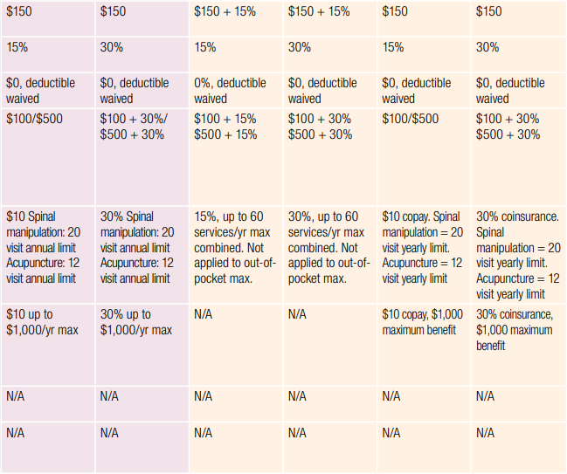
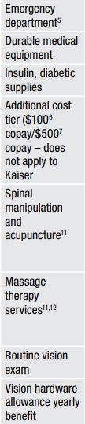
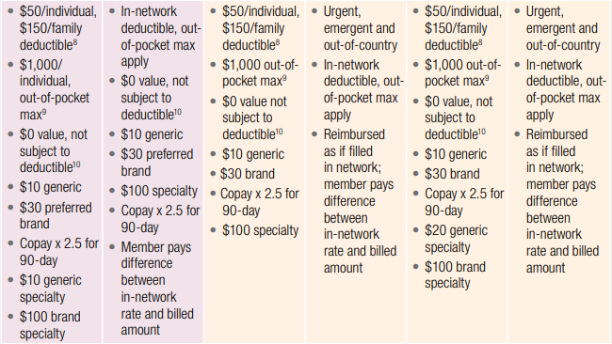
Medical | Total | Employee | Total | Employee | Total | Employee
Premium | Moda | Share | Statewide | Share | Choice | Share
EE Only | $827.06 | $89.28 | $929.03 | $191.25 | $810.75 | $72.97
EE+ Child(ren) | $1,405.99 | $151.76 | $1,579.35 | $325.12 | $1,378.27 | $124.04
EE + Spouse | $1,654.12 | $178.56 | $1,858.07 | $382.51 | $1,621.49 | $145.93
Family | $2,233.07 | $241.06 | $2,508.39 | $516.38 | $2,189.02 | $197.01

